General Information
- Scientific name: Pavo cristatus
- Family: Phasianidae (same family as pheasants)
- Native range: Indian subcontinent — found across India, Sri Lanka, and parts of Myanmar.
- National bird of India: Symbolizes grace, pride, and beauty.
Natural Habitat
- Prefers open forests, farmlands, and grasslands near water sources.
- Commonly seen in semi-dry regions and village outskirts where food and shelter are abundant.
- Roosts on tall trees at night to stay safe from predators.
Food Habits
Peacocks are omnivorous:
- Plant-based: Seeds, grains, fruits, berries, and tender shoots.
- Animal-based: Insects, small reptiles, frogs, and even snakes.
- They help control pests in agricultural areas — a natural benefit to farmers.
Colors and Appearance
Behavior and Breeding
- Breeding season: Monsoon months (June–September).
- Males perform elaborate dances and calls to attract females.
- Females lay 3–6 eggs in shallow ground nests.
- Chicks can walk and feed themselves within hours of hatching.
Availability and Conservation
- Widely distributed across India, Sri Lanka, and introduced in Africa, Australia, and U.S. parks.
- Protected under Schedule I of the Indian Wildlife Protection Act, 1972.
- Threats include habitat loss and illegal hunting for feathers, though populations remain stable in many regions.
Cultural Significance
- Associated with Lord Krishna and Goddess Saraswati in Indian mythology.
- Represents beauty, immortality, and spiritual awakening in many cultures.
- Its feathers are often used in art, decoration, and traditional rituals.
Below table shows how many peacocks available on each country
country | peacock count
Portugal | 10
Spain | 10
India | 500
Australia | 55
UAE | 10
UK | 10
Above table shown how many peacocks available on each country

Below table shows the incharge of animals based on every country
Incharge name | Department | Country
Jeyaseelan | Central Animal Welfare | Portugal
Purus | Anilmal Husbandry | Spain
Rishi | Anilmal Welfare | UK
Liokios | Animal Safety | UAE

above table shows the incharge of animals based on every country

the below picture is about the dancing peacock
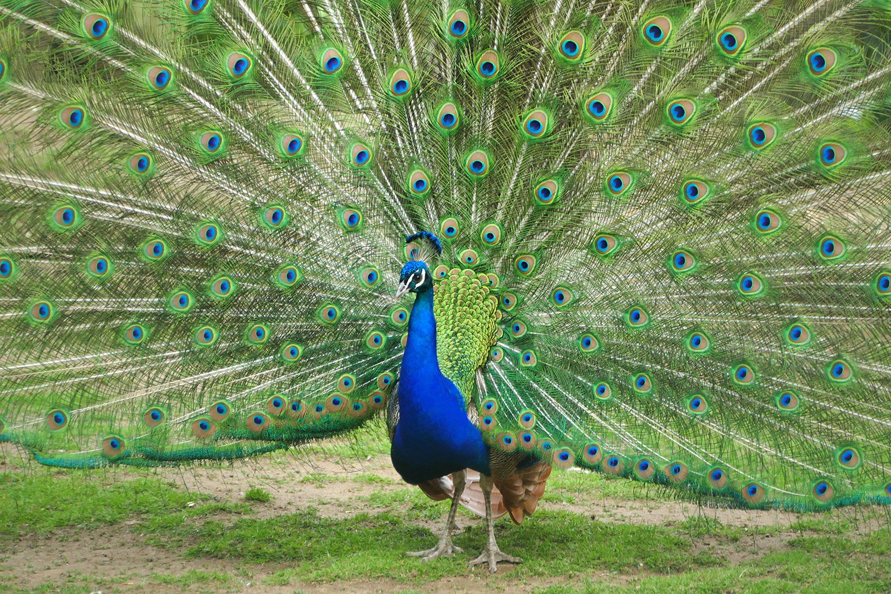
the above picture is about the dancing peacock

